**Year 9 Reading Journal**

**Preparation for: AQA GCSE English Literature/Language**

* Preparation for approaching GCSE set texts
* Reading for meaning (and pleasure!)
* **Assessment Objective 1 (language and Literature: Read, understand and respond to texts**
* **Assessment Objective 2 (Language): Explain, comment on and analyse how writers use language to achieve effects/influence readers. Use relevant subject terminology to support views**

**"There is more treasure in books than in all the pirate's loot on Treasure Island." – Walt Disney**

**“If you don’t like to read, you haven’t found the right book.” – J.K. Rowling**

**“I guess there are never enough books.” – John Steinbeck**

**“Somebody who only reads newspapers and at best books of contemporary authors looks to me like an extremely near-sighted person. He is completely dependent on the prejudices and fashions of his times, since he never gets to see or hear anything else.” – Albert Einstein**

**“These books gave Matilda a hopeful and comforting message: You are not alone.” – Roald Dahl**

**“In the case of good books, the point is not to see how many of them you can get through, but rather how many can get through to you.” – Mortimer J. Adler**

Read through this information carefully. It will explain **WHAT** this journal is going to guide and prepare you for and **WHY** it is important that you make sure this work is completed within the time set.

**Introduction: Why Am I Doing This?**

As part of your English Language and Literature GCSE you will need to develop your reading skills, particularly for the assessment objectives on the front cover of this reading journal. **These core objectives will be used to assess around 75% of your exams!**

.

.

By working through the tasks in this journal it will help to develop these skills (which you have been working on throughout Year 9).

**The Focus Of Each Reading Lesson**

You should read your chosen novel for around 35-40 minutes (set a timer on your phone). Next complete the page of your journal (one per lesson). This should include the title of the book, the date and the length of time you have read. Lastly, complete answers to the questions for each section in your journal in as much detail as possible. What can you learn or infer (what is suggested, rather than what you are told)? See the example below.

**Lesson 1**

What was your favourite part of the reading today?

**I liked the introduction of Lennie and George. They seem to be like brothers, but Lennie is more like a child, who follows George and copies his actions. Their argument about beans made me laugh because …**

**Book Of Mice And men**

**Date 23/04/20**

**Minutes read 35 minutes**

If you are a keen reader, you can complete more journal entries than the minimum 5 lessons leading up to half-term. Use the **Vocabulary Expander** at the end of this journal to record any new words and definitions. Remember to keep your journal safe for your return to school!

**Once you are back at school, your teacher will take in your booklet and check you have completed the tasks. You may be asked to share your ideas (informally) about your book/s. Please DO NOT lose this booklet. It MUST be handed in to your teacher once you are back in school- otherwise you risk having to do it all again.**

**You may wish to complete this booklet in a couple of ways:**

* **Print out and complete in the booklet by hand;**
* **Complete it on the computer, and print it when we are back at school;**
* **Print off separate lessons, so you can see how much you would need to complete in a week.**

**Your timetable:**

We know that working from home is new to you and it can be hard to get organised!

Therefore, we have created the timetable below.

It shows you on **what days you would have normally had an English lesson** on and **how many hours a week** you should be spending on completing English work. As there are two different booklets to be working through, we have also made it clear which booklet you should be working on for the lesson. **Make sure you are following this timetable!**

.

**Task:** To make it clear to you, if you are in a 9X class highlight/ colour in all of the 9X lessons- do the same if you are in a 9Y class (but of course highlight/colour the 9Y lessons).

**The timetable starts after the Easter holidays:**

|  |  |  |  |  |  |  |
| --- | --- | --- | --- | --- | --- | --- |
|  | **Monday** | **Tuesday** | **Wednesday** | **Thursday** | **Friday** | **How many hours should I spend on English this week?** |
| **Week 1    B**  **(20/04/20)** | ***9X*** (Reading Booklet) | ***9Y***  (Reading Booklet) | ***9X*** (Speaking and Listening) | ***9X*** (Speaking and Listening) | ***9Y***  (Speaking and Listening) | 9Y = 2 hours  9X = 3 hours |
| **Week 2    A**  **(27/04/20)** | ***9Y***  (Speaking and listening)    ***9X*** (Reading Booklet) | ***9Y***  (Reading Booklet)    ***9X*** (Speaking and Listening) | ***9Y***  (Speaking and listening) | ***9Y***  (Speaking and listening)    ***9X*** (Speaking and Listening) | ***9Y***  (Speaking and listening)    ***9X*** (Speaking and Listening) | 9Y = 5 hours  9X = 4 hours |
| **Week 3    B**  **(4/05/20)** | ***9X*** (Reading Booklet) | ***9Y***  (Reading Booklet) | ***9X*** (Speaking and Listening) | ***9X*** (Speaking and Listening) | ***9Y***  (Speaking and Listening) | 9Y = 2 hours  9X = 3 hours |
| **Week 4    A**  **(11/05/20)** | ***9Y***  (Speaking and listening)    ***9X*** (Reading Booklet) | ***9Y***  (Reading Booklet)    ***9X*** (Speaking and Listening) | ***9Y***  (Speaking and listening) | ***9Y***  (Speaking and listening)    ***9X*** (Speaking and Listening) | ***9Y***  (Speaking and listening)    ***9X*** (Speaking and Listening) | 9Y = 5 hours  9X = 4 hours |
| **Week 5    B**  **(18/05/20)** | ***9X*** (Reading Booklet) | ***9Y***  (Reading Booklet) | ***9X*** (Speaking and Listening) | ***9X*** (Speaking and Listening) | ***9Y***  (Speaking and Listening) | 9Y = 2 hours  9X = 3 hours |

**Why Read?**

**You may love reading or may find it a real effort. Try to look at the bigger picture and beyond English as a subject …Reading regularly helps improve literacy, your ability in other subjects and can help you reach your future goals/dream job! Read the quotations below and highlight/underline any that you think might agree with your view of reading. You only need 2 or 3.**

1. “A reader lives a thousand lives before he dies . . . The man who never reads lives only one.” – George R.R. Martin
2. “Never trust anyone who has not brought a book with them.” – Lemony Snicket
3. “You can never get a cup of tea large enough or a book long enough to suit me.” – C.S. Lewis
4. “Reading is essential for those who seek to rise above the ordinary.” – Jim Rohn
5. “I find television very educating. Every time somebody turns on the set, I go into the other room and read a book.” – Groucho Marx
6. “‘Classic’ – a book which people praise and don’t read.” – Mark Twain
7. "So please, oh please, we beg, we pray, go throw your TV set away, and in its place you can install a lovely bookshelf on the wall." – Roald Dahl
8. “Think before you speak. Read before you think.” – Fran Lebowitz
9. “The reading of all good books is like conversation with the finest (people) of the past centuries.” – Descartes
10. “In the case of good books, the point is not to see how many of them you can get through, but rather how many can get through to you.” – Mortimer J. Adler
11. “The more that you read, the more things you will know. The more that you learn, the more places you’ll go.” – Dr. Seuss
12. “Books are a uniquely portable magic.” – Stephen King
13. “I read a book one day and my whole life was changed.” – Orhan Pamuk
14. “Today a reader, tomorrow a leader.” – Margaret Fuller
15. “People can lose their lives in libraries. They ought to be warned.” – Saul Bellow
16. “A good book is an event in my life.” – Stendhal
17. “Reading brings us unknown friends” – Honoré de Balzac
18. “Once you have read a book you care about, some part of it is always with you.” – Louis L’Amour
19. "There is more treasure in books than in all the pirate's loot on Treasure Island." – Walt Disney
20. “Books to the ceiling, Books to the sky, My pile of books is a mile high. How I love them! How I need them! I’ll have a long beard by the time I read them.” – Arnold Lobel
21. “There is nothing more luxurious than eating while you read—unless it be reading while you eat.” – E. Nesbit
22. “One glance at a book and you hear the voice of another person, perhaps someone dead for 1,000 years. To read is to voyage through time.” – Carl Sagan
23. “I have a passion for teaching kids to become readers, to become comfortable with a book, not daunted. Books shouldn’t be daunting, they should be funny, exciting and wonderful; and learning to be a reader gives a terrific advantage.” – Roald Dahl
24. “You know you’ve read a good book when you turn the last page and feel a little as if you have lost a friend.” – Paul Sweeney
25. “Some books leave us free and some books make us free.” – Ralph Waldo Emerson
26. “Once you learn to read, you will be forever free.” – Frederick Douglas
27. “You may have tangible wealth untold. Caskets of jewels and coffers of gold. Richer than I you can never be — I had a mother who read to me.” – Strickland Gillilan
28. “To learn to read is to light a fire; every syllable that is spelled out is a spark.” – Victor Hugo
29. “Fill your house with stacks of books, in all the crannies and all the nooks.” – Dr. Seuss
30. “Show me a family of readers, and I will show you the people who move the world.” – Napoléon Bonaparte
31. “A classic is a book that has never finished saying what it has to say.” – Italo Calvino
32. “I have always imagined that paradise will be a kind of library.” – Jorge Luis Borges
33. “No entertainment is so cheap as reading, nor any pleasure so lasting.” – Mary Wortley Montagu
34. “If you are going to get anywhere in life you have to read a lot of books.” – Roald Dahl
35. “To acquire the habit of reading is to construct for yourself a refuge from almost all the miseries of life.” – W. Somerset Maugham
36. “Rainy days should be spent at home with a cup of tea and a good book.” – Bill Watterson
37. “These books gave Matilda a hopeful and comforting message: You are not alone.” – Roald Dahl
38. “I guess there are never enough books.” – John Steinbeck
39. “If you don’t like to read, you haven’t found the right book.” – J.K. Rowling
40. Books are good company, in sad times and happy times, for books are people – people who have managed to stay alive by hiding between the covers of a book.” – E.B. White
41. “Outside of a dog, a book is a man’s best friend. Inside of a dog, it’s too dark to read.” – Groucho Marx
42. “Somebody who only reads newspapers and at best books of contemporary authors looks to me like an extremely near-sighted person who scorns eyeglasses. He is completely dependent on the prejudices and fashions of his times, since he never gets to see or hear anything else.” – Albert Einstein
43. “Employ your time in improving yourself by other men’s writings so that you shall come easily by what others have labored hard for.” – Socrates
44. “A children’s story that can only be enjoyed by children is not a good children’s story in the slightest.” – C.S. Lewis

**“A reader lives a thousand lives before he dies . . . The man who never reads lives only one.” – George R.R. Martin**

**“You know you’ve read a good book when you turn the last page and feel a little as if you have lost a friend.” – Paul Sweeney**

**Getting Started**

**To help with ideas, you will find a recommended Crofton Reading List on the next page for Year 9.**

**If you do not have a book to hand, try downloading free novels from the play store (Google/Apple etc.). If this is not possible, there is a link below for “Audible”, a company that is offering free access to audio books. There is no need to sign up! There are different categories, such as “Teens”. A selection are shown on the next few pages – but there are lots more!**

<https://stories.audible.com/discovery>

**Books are good company, in sad times and happy times, for books are people – people who have managed to stay alive by hiding between the covers of a book.” – E.B. White**

**“The more that you read, the more things you will know. The more that you learn, the more places you’ll go.” – Dr. Seuss**

**“Once you have read a book you care about, some part of it is always with you.” – Louis L’Amour**

**Recommended Novels for Personal Reading**



**Year 9**

‘Noughts and Crosses’ Malorie Blackman

‘Are you there God? It’s me, Margaret’ Judy Blume

‘Wuthering Heights’ Emily Bronte

‘Boy Proof’ Cecil Castelluchi

‘The Hunger Games - Mockingjay’ Suzanne Collins

‘The Chocolate War’ Robert Cormier

‘Paddy Clarke Ha Ha Ha’ Roddy Doyle

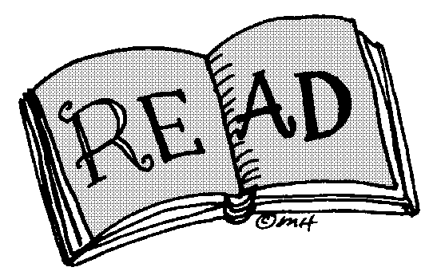 ‘Oliver Twist’ Charles Dickens

‘Before I Die’ Jenny Downham

‘Looking for Alaska’ John Green

The Goose Girl’ Shannon Hale

‘The Woman in Black’ Susan Hill

‘Brave New World’ Aldous Huxley

‘The Road’ Cormac McCarthy

‘Twilight’ Stephanie Meyer

‘To Kill a Mockingbird’ Harper Lee

‘The Call of the Wild’ Jack London

‘The Giver’ Louis Lowry

‘Hatchet’ Gary Paulsen

‘My Sister’s Keeper’ Jodi Picot

‘Discworld’ Terry Pratchett

‘Witch Child’ Celia Rees

‘Harry Potter and the Goblet of Fire’ J K Rowling

‘The Card Turner’ Louis Sachar

‘Stone Cold’ Robert Swindells

‘The Lord of the Rings’ JRR Tolkein

‘Uglies’ Scott Westerfield

‘The Color Purple’ Alice Walker

‘The Day of the Triffids’ John Wyndham

‘The Book Thief’ Marcus Zusak

[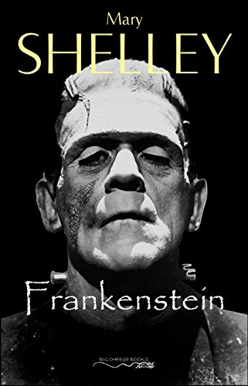](https://www.google.com/url?sa=i&url=https%3A%2F%2Fwww.amazon.co.uk%2FFrankenstein-Mary-Shelley-ebook%2Fdp%2FB0771T61V7&psig=AOvVaw0uW_wXzD0odjfP_tW1MT36&ust=1585741544954000&source=images&cd=vfe&ved=0CAIQjRxqFwoTCIjnt97RxOgCFQAAAAAdAAAAABAE)

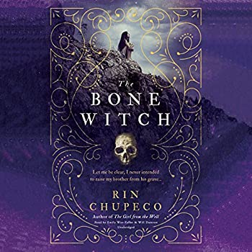

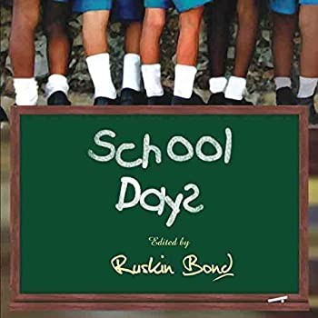

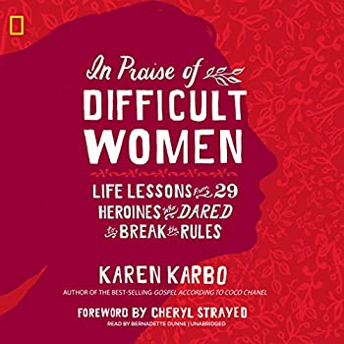

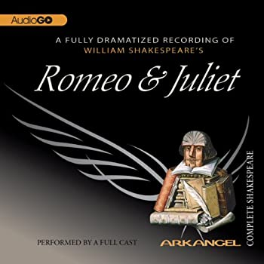

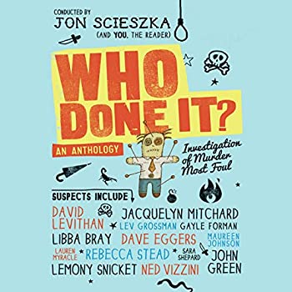

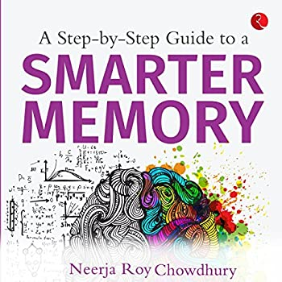



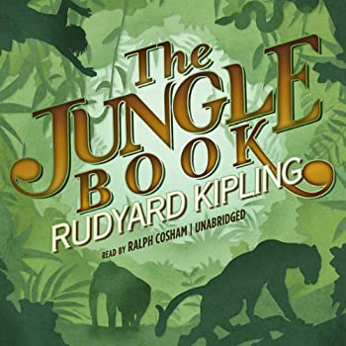



<https://stories.audible.com/discovery>

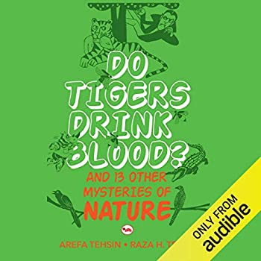

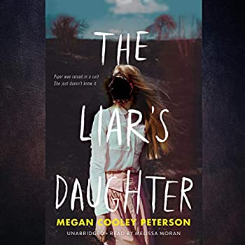

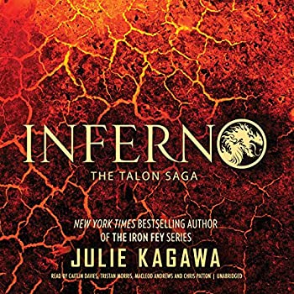

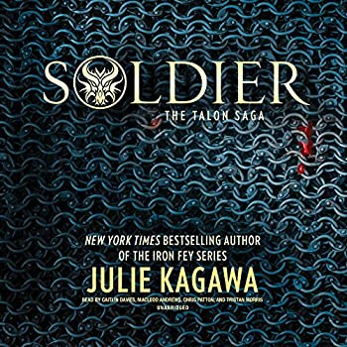

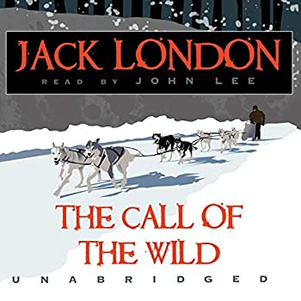

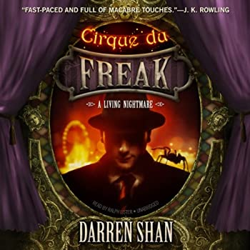

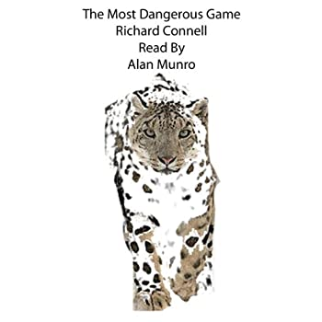

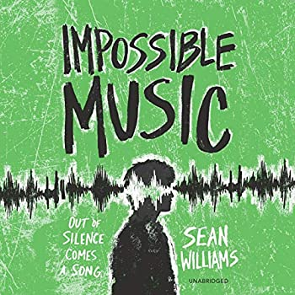

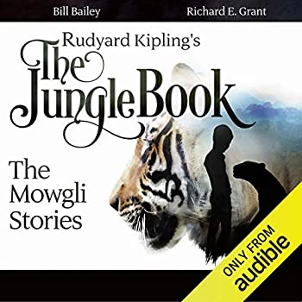

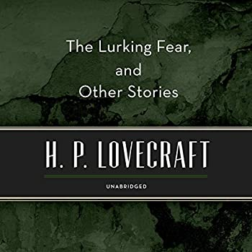

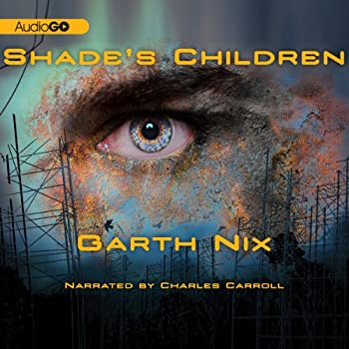

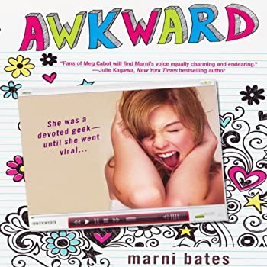

Reading Journal

|  |  |
| --- | --- |
|  |  |
|  |  |
|  |  |
|  |  |
|  |  |

Book

Date

Minutes read

**Lesson 1**

What was your favourite part of the reading today?

What reaction do you think the author wanted you to have with what you read today?

List at least 5 nouns from what you read today.

Write them down in alphabetical order.

List 5 nouns from the reading today but in reverse alphabetical order.

What do you think will happen next to the main character? Why?

|  |  |
| --- | --- |
|  |  |
|  |  |
|  |  |
|  |  |
|  |  |

Book

Date

Minutes read

**Lesson 2**

List at least 3 adjectives and 2 adverbs that you read today. List them in alphabetical order.

Find 3 adverbs anywhere in the book. Write them below. For each add an antonym (a word with the opposite meaning).

Choose an adjective from anywhere in the book. List at least 3 other ways of describing the same the thing (synonyms).

Write down one thing the main character did in your reading today. Why do you think that they acted in that way?

If you could change one thing about the story so far, what would it be and why?

Reading Journal

|  |  |
| --- | --- |
|  |  |
|  |  |
|  |  |
|  |  |
|  |  |

**Lesson 3**

List 5 words that started sentences that you read today. Write them down in alphabetical order.

Copy down your favourite sentence from the book so far.

Re-write your favourite sentence from above by adding different adjectives and/or adverbs.

Using exactly 17 words, describe what happened in what you read today.

List 5 verbs you read today. List them in alphabetical order.

Reading Journal

Reading Journal

|  |  |
| --- | --- |
|  |  |
|  |  |
|  |  |
|  |  |
|  |  |

**Lesson 4**

What was the purpose of the story in what you read today? Did it change or develop the story or add anything new?

In no less than 25 words, describe what you think the main character would look like after what you read today.

Describe your emotions when reading today. Include reasons why.

What is your prediction for what will happen in the next chapter?

Using exactly 12 words, and including at least 2 adjectives, describe how you felt reading today.

Reading Journal

|  |  |
| --- | --- |
|  |  |
|  |  |
|  |  |
|  |  |
|  |  |

**Lesson 5**

Write down and list in alphabetical order your 7 favourite words from the reading today.

What reaction do you think the author wanted you to have with what you read today? What words did they use to help create that reaction?

Looking back through what you read, write down at least one 3 syllable word, one 4 syllable word and any 5 syllable words.

If you had to recommend the book you are reading for someone, who do you think would it enjoy it the most. Why?

Write down one thing the main character did in your reading today. Why do you think that they acted in that way?

Reading Journal

|  |  |
| --- | --- |
|  |  |
|  |  |
|  |  |
|  |  |
|  |  |

**Lesson 6**

List your 6 favourite words from anywhere in the book. For each, try to write down a word that rhymes with it.

What do you expect to happen in the next chapter of the book?

Write down 5 verbs from anywhere in the book. List them in reverse alphabetical order.

In exactly 15 words, describe what happened in the reading today.

Without looking, write down what you think the last sentence of the book will be.

Reading Journal

|  |  |
| --- | --- |
|  |  |
|  |  |
|  |  |
|  |  |
|  |  |

Book

Date

Minutes read

**Lesson 7**

If you could change one thing about one the main characters, what would you change and why?

What do you think the author wanted you to feel with what you read today? Write down at least 2 words that helped to create this reaction.

What was your favourite sentence from what you read today? Copy it down exactly as it appears in the book.

Find 3 adverbs anywhere in the book. Write them below. For each add an antonym (a word with the opposite meaning).

In no more than 10 words, sum up what happened in the reading you did today.

**Lesson 8**

Describe the order of events in what you read today using the words below.

To begin with…

Then…

And then near the end…

Reading Journal

|  |  |
| --- | --- |
|  |  |
|  |  |
|  |  |
|  |  |
|  |  |

Book

Date

Minutes read

List at least 5 of the adjectives (descriptive words) that the author used in what you read today.

Write down 5 adverbs from the book so far. For each one write down the opposite meaning (antonyms).

Using exactly 17 words, describe what happened in what you read today.

Write down the names of all of the characters that featured in what you read today. Alphabetise them backwards, from Z-A.

Reading Journal

|  |  |
| --- | --- |
|  |  |
|  |  |
|  |  |
|  |  |
|  |  |

Book

Date

Minutes read

**Lesson 9**

If you could change one thing that happened in what you read today, what would you change and why?

Write down 5 words that started sentences but list them in alphabetical order.

Write down and list in alphabetical order your 7 favourite words from the reading today.

What did you learn about the main character today?

Describe your emotions reading today. Include reasons why.

Reading Journal

|  |  |
| --- | --- |
|  |  |
|  |  |
|  |  |
|  |  |
|  |  |

Book

Date

Minutes read

**Lesson 10**

Describe what happened in what you read today using the bullet points below:



List your 6 favourite words from anywhere in the book. For each, try to write down a word that rhymes with it.

List at least 5 nouns from what you read today.

Write them down in alphabetical order.

List 5 nouns from the reading today but in reverse alphabetical order.

What do you think will happen next to the main character? Why?

Reading Journal

|  |  |
| --- | --- |
|  |  |
|  |  |
|  |  |
|  |  |
|  |  |

Book

Date

Minutes read

**Lesson 11**

List at least 3 adjectives and 2 adverbs that you read today. List them in alphabetical order.

Find 3 adverbs anywhere in the book. Write them below. For each add an antonym (a word with the opposite meaning).

Write down one thing the main character did in your reading today. Why do you think that they acted in that way?

Choose an adjective from anywhere in the book. List at least 3 other ways of describing the same the thing (synonyms).

If you could change one thing about the story so far, what would it be and why?

Reading Journal

|  |  |
| --- | --- |
|  |  |
|  |  |
|  |  |
|  |  |
|  |  |

Book

Date

Minutes read

**Lesson 12**

List 5 words that started sentences that you read today. Write them down in alphabetical order.

List 5 verbs you read today. List them in alphabetical order.

In no less than 25 words, describe what you think the main character would look like after what you read today.

What was the purpose of the story in what you read today? Did it change or develop the story or add anything new?

Looking back through what you read, write down at least one 3 syllable word, one 4 syllable word and any 5 syllable words.

Reading Journal

**Vocabulary Expander**

Use the next few pages to record any words you weren’t sure of the meaning of. Use a dictionary and look up the word class (for example noun, adjective etc.) and then copy the definition into the box on the right.

|  |  |  |
| --- | --- | --- |
| Word: | Word class: | Definition: |
| Apprehensive | Adjective | anxious or fearful that something bad or unpleasant will happen.  "he felt apprehensive about going home"  *synonyms:*  [anxious](https://www.bing.com/search?q=define+anxious&FORM=DCTRQY) · [alarmed](https://www.bing.com/search?q=define+alarmed&FORM=DCTRQY) · [worried](https://www.bing.com/search?q=define+worried&FORM=DCTRQY) · [uneasy](https://www.bing.com/search?q=define+uneasy&FORM=DCTRQY) · [nervous](https://www.bing.com/search?q=define+nervous&FORM=DCTRQY) · [concerned](https://www.bing.com/search?q=define+concerned&FORM=DCTRQY) · [agitated](https://www.bing.com/search?q=define+agitated&FORM=DCTRQY) |
|  |  |  |
|  |  |  |
|  |  |  |
|  |  |  |
|  |  |  |
|  |  |  |
|  |  |  |
|  |  |  |
|  |  |  |
|  |  |  |
|  |  |  |

Reading Journal

|  |  |  |
| --- | --- | --- |
| Word: | Word class: | Definition: |
|  |  |  |
|  |  |  |
|  |  |  |
|  |  |  |
|  |  |  |
|  |  |  |
|  |  |  |
|  |  |  |
|  |  |  |
|  |  |  |
|  |  |  |
|  |  |  |
|  |  |  |

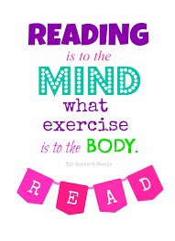

Please get your parents/carers to sign below to show you have completed the reading:

I hereby certify that _______________ has completed their reading for the designated lesson time.

Signed: