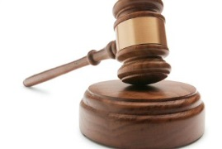  Article 48 | The President could make laws in ‘an emergency’ without going to the Reichstag. There was no definition of an emergency! Created a weak government.
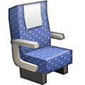  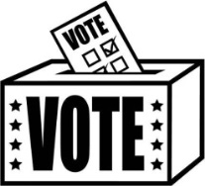  Proportional Representation | In elections, the % of votes= the % of seats in the Reichstag.  Meant there were lots of small parties in the Reichstag= difficult to agree and make decisions.
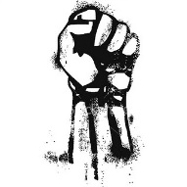  Spartacist Uprising 1919  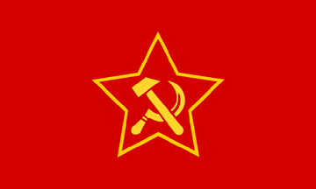 | - Led by Rosa Luxemburg and Karl Liebknecht: a group of radical socialists.  - A revolt against the government. Took over newspaper and other buildings  - The Freikorps were brought in by the government to stop the revolt.  - Both Rosa and Karl are killed.
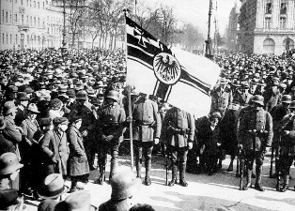  Kapp Putsch 1920 | Dr Wolfgang Kapp and his band of Freikorps try to take Berlin. Weimar Government flees to countryside. Kapp takes over the city.  Government ask the people of Berlin to hold a general strike. They agree- this means water, electricity are off, transport suspended shops and banks closed. Berlin is at a stand-still and cannot be ruled. Kapp has failed and flees to Sweden.
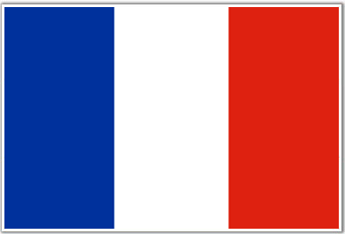  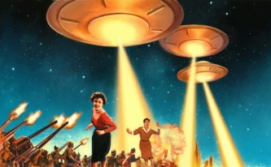  1923: Invasion of the Ruhr | Germany failed to pay their first reparations payment in 1922. French troops invade the Ruhr (industrial heartland of Germany) and occupy this terriotory. They want to take back what they are owed in raw materials.  German workers in the Ruhr passively resist the French and refuse to work.  With no goods being made, the German government has no money and so prints it to ensure the workers are still paid.
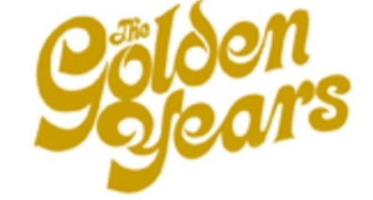  1924-1929 | RECOVERED  - New currency- Rentenmark  - Locarno/ Kellogg Briand  - Dawes and Young Plans  - Culture thriving  NOT RECOVERED  - Recovery based on borrowed US money  - Many disapproved of Liberal culture
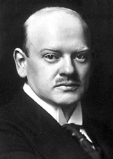  Stresemann | Born in 1878 and died in 1929.  Stresemann took Weimar Germany out of its darkest hour – hyperinflation – to the so-called ‘Golden Years of Weimar’.  August 1923- November 1923: Chancellor  November 1923- 1929: Foreign Minister until his death.
Nazis 1920s  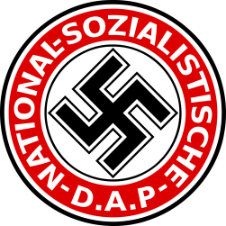 | - Started as German Workers Party in 1919 by Anton Drexler. Hitler becomes leader in 1921  - 25 point programme/ SA set up/ Newspaper  - Swastika and branding started  - 1923 Munich Putsch- failure/ success
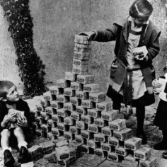  1923: Hyperinflation | (Germany couldn’t pay reparations and still recovering from WW1)  Government printed money to solve economic problems. Prices ran out of control - eg a loaf of bread, which cost 250 marks in January 1923 had risen to 200,000 million marks in November 1923. German's currency became worthless.  Some benefit and some lose out…who?
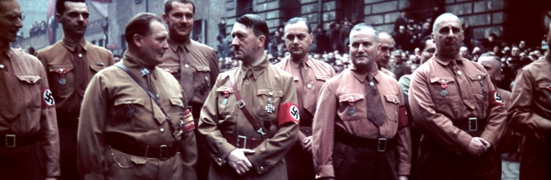  1923: Munich Putsch | The Nazi attempt of seize power in Munich.  Met in a beer hall to organise, had the support of the Bavarian government: von Kahr and Lossow. Nazis march into Munich but are shot at by the German army and the putsch fails. They were betrayed by von Kahr and Lossow.  Hitler arrested and given 9 months in Lansberg prison where he writes Mein Kampf.  Positives and negatives of the Putsch?
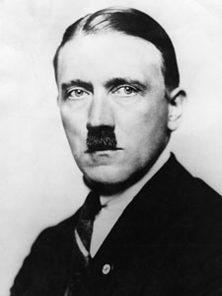  Hitler’s Rise to Chancellor | Long term bitterness  Ineffective Constitution  Money  Personality  Propaganda  Attacks on other parties  Programme  Economic Depression  Recruited by Hindenburg
Reichstag Fire  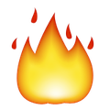  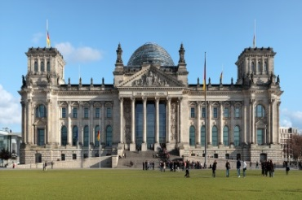 | 27 February 1933: arson attack. Very convenient for the Nazis. Van de Lubbe (Dutch Communist) blamed and killed. Was it the Nazis? Two advantages:  - Imprisoned many communist leaders, which got rid of opposition.  - They could say the country was in danger from the communists.
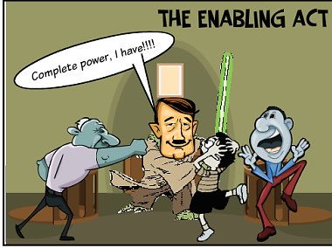  Enabling Act | After the Reichstag Fire, Hitler claimed there was a risk of a communist revolution.  He used this frenzy to pass the enabling act which enabled him to pass laws without going to the Reichstag. He did not have a majority in March 1933 and so asked the Centre and Nationalist parties to support him in return for favours.
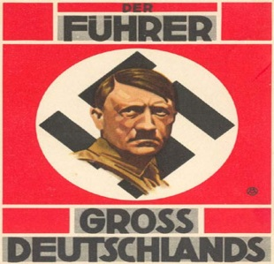  From Chancellor to Fuhrer | Rigged Reichstag Fire  German General Election  Election Enabling Act  Leads Local Governments  To Trade Unions  Psychopath Political parties  Nazi Night of the Long Knives  Fuhrer Fuhrer (Hindenburg dies)
The Night of the Long Knives  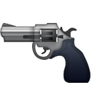 | Hitler wants to replace the SA with the SS as they had become difficult to handle. Also, there were rumours that many of the leaders, including Rohm were homosexual. Over 400 people were shot including Rohm, Strasser and von Schliecher. Hindenburg thanked Hitler for stopping a revolution.
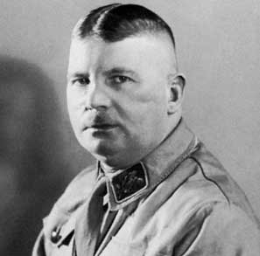  Ernst Rohm | Leader of the SA  Loyal friend to Hitler.  Killed in 1934 in the Night of the Long Knives
Joseph Goebbels | 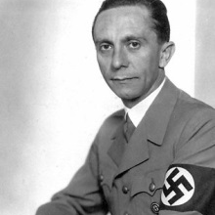  Minister of Propaganda, 1933–45
Hermann Goering  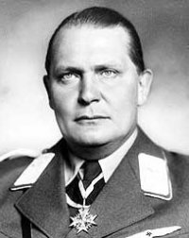 | Appointed Prime Minister and Interior Minister for Prussia and was given control of the Luftwaffe – Germany’s growing air force.
Heinrich Himmler  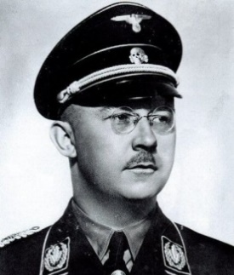 | - Nazi party's propaganda leader between 1926 and 1930.  - 1929: appointed head of the SS,  - 1933: set up Dachau, the first Nazi concentration camp.  - 1943: appointed minister for the interior. In this post he oversaw the 'Final Solution' In charge of Concentration camps.
Reinhard Heydrich | One of the main architects of the Holocaust.  Head of the Gestapo.
Rudolf Hess  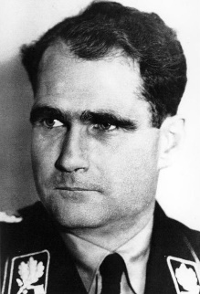 | Deputy leader of the Nazi Party
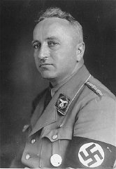  Dr Robert Ley | Head of the German Labour Front - he established the Strength Through Joy scheme.
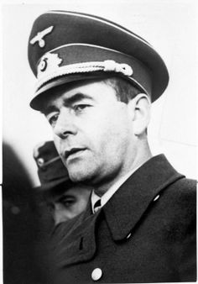  Albert Speer | Minister for rearmament and war production in 1942
Reichstag | The German parliament where the government meets to decide on laws.  Has members of the Reichstag voted in by the German people.
Treaty of Versailles  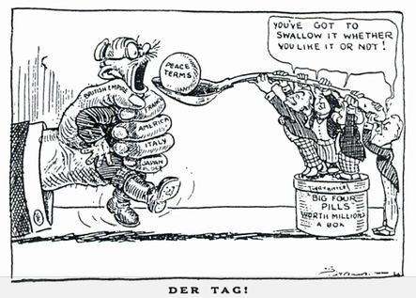 | The agreement made after WW1.  - Germany forced to accept war guilt  - Army limited to 100,000 men  - Land and empire taken away  - No submarines  German people are bitter about this, especially Hitler and the Nazis.
November Criminals  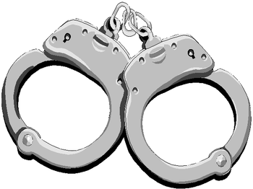 | The nickname given by opponents to the Weimar Government. Many blamed the government for signing the Treaty of Versailles.
Freikorps | Right wing Ex-soldiers. Helped stop the Spartacist Uprising and then staged the Kapp Putsch against the government. Hated the Weimar Government but hated the Communists more. Many became SA in the Nazis Party.
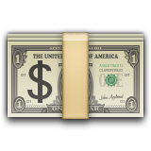  Wall Street Crash | When the Stock Market in America crashed. Many people lost 1000’s overnight. This affected Germany as America recalled their loans which they had lent to Germany to help pay war reparations. Germany left in crisis.
Great Depression  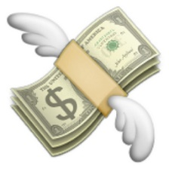 | The period of time which followed the Wall Street Crash. Huge unemployment, food shortages and hatred of the Government. Hitler and the Nazis used this time to gain power. Seen as Germany’s last hope.
Reparations  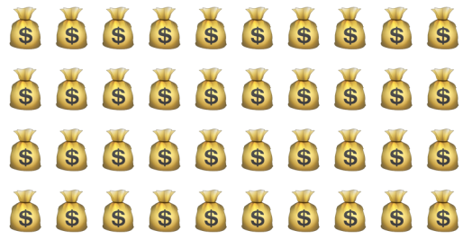 | Money Germany was forced to pay after the First World War  $6.6 Billion
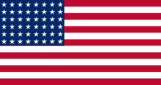  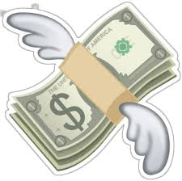  Dawes Plan | 1924  Money loaned to Germany from America to help pay back reparations payments. The committee, headed by US Charles Dawes helped restructure Germany’s economy to aid recovery.
Weimar Culture | - singer/actress: Marlene Dietrich  - architect: Gropius the leader of the Bauhaus movement  - artists: Paul Klee and Otto Dix  - writer: Erich Maria Remarque who wrote 'All Quiet on the Western Front'  - film-maker: Fritz Lang
Concordat | Hitler makes an agreement with the Pope who sees him as someone who can destroy communism. This agreement allows Hitler to take over political power in Germany as long as he leaves the Catholic Church alone.
SS | Schutzstaffel. Led by Henrich Himmler. Blackshirts, specially chosen men.  Role: to protect the Nazi leaders.  1929: fewer than 300 members of the SS whilst the number of SA members was growing..
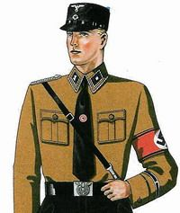  SA | Sturm-Abteilung / Stormtroopers / Brown shirts. Set up in 1921 and led by Ernest Rohm.  Purpose: to interrupt the meetings of Nazi opponents/ protected Nazi supporters/ distributed propaganda leaflets/ very organised, therefore had a good reputation
Gestapo  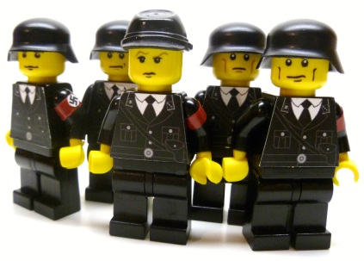 | Under direct control of Himmler  The feared secret police, said to be listening ‘everywhere’ The Gestapo’s main purpose was to hunt out those considered a threat to Nazi Germany (Jews, Communists, Jehovah Witnesses, homosexuals)
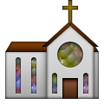  Children Kitchen Church | Women were expected to stay at home and look after the family.  Women doctors, teachers and civil servants were forced to give up their careers. Even at the end of the war, women were never asked to serve in the armed forces.  Their job was to keep the home nice for their husband and family. Large ‘pure’ families encouraged.
Aryan | The ‘master race’ created by the Nazis. They were seen to be ‘pure’ German people (not Jewish)
White Rose movement  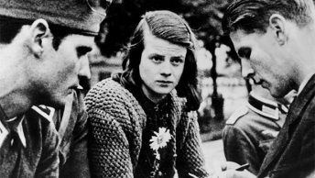 | Students at Munich University - Hans and Sophie Scholl, and Christopher Probst. Their opposition was non-violent.  18 February 1934 – they were arrested by the Gestapo for distributing anti-Nazi leaflets, displaying posters and writing graffiti. They were tortured and hanged.
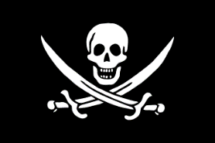  Edelweiss Pirates | They daubed anti-Nazi slogans, sheltered deserters and beat up Nazi officials. In 1944, the Cologne Pirates (the Edelweiss Pirates based in Cologne) killed the Gestapo chief, so the Nazis publicly hanged 12 of them.
The Swing Kids  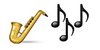 | Middle class. Inspired by the music of Britain and the USA – especially jazz. Swing clubs were opened where people danced the jitterbug. They listened to music that had been banned.
Persecution | Tried to eliminate the Jews. Killed 85 per cent of Germany's Gypsies. Sterilised black people. Killed mentally ill patients. Sterilised physically disabled people. Sterilised deaf people. Put homosexuals, prostitutes, Jehovah's Witnesses, alcoholics, pacifists, beggars, hooligans and criminals into concentration camps.
Nuremburg Laws  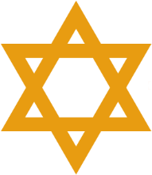  1935 | Nuremberg laws (15 September) Jews could not be citizens. They were not allowed to vote or to marry a German.
Kristallnacht  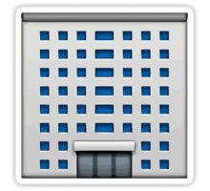  1938 | ‘The Night of the broken glass’ (9 November) - attacks on Jewish homes, businesses and synagogues.
Wansee Conference | 20 January 1942 decided on the Final Solution, which was to gas all Europe's Jews. The main death camps were at Auschwitz, Treblinka and Sobibor.
Final Solution | ‘The Final Solution to the Jewish Question’ was a German plan for the extermination of the Jews during World War II. This involved building death camps all over Europe.
Religious Opposition | - Catholic Archbishop of Munster, von Galen, tried to end euthanasia of mentally-disabled people.  - 1937, the Pope's message attacked Hitler as 'a mad prophet with repulsive arrogance'  - Martin Niemöller, formed the Confessional Church. Niemöller was held in a concentration camp. Dietrich Bonhöffer, took part in the 1944 bomb plot and was executed
Kreisau Circle  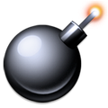 | 1944, a group of army officers tried to bomb Hitler. The bomb was planted by Colonel Stauffenberg. It exploded, but Hitler survived. In retaliation, 5,000 people were executed.
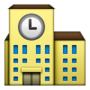  School s | Non-Nazi teachers and university professors were sacked; teachers had to join the National Socialist Teachers' League.  Textbooks were re-written to include Nazi political and racial ideas. History was taught to glorify Germany. There was a concentration on physical fitness. Girls were taught cookery; boys were taught science and maths.
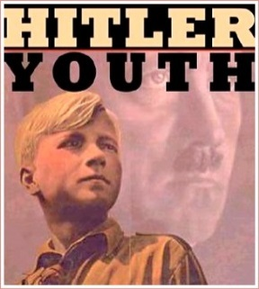  Youth | The Hitler Youth catered for 10 to 18 year olds. By 1933 its membership stood at 100,000. In 1936, the figure stood at 4 million members. In 1936, it became compulsory to join the Hitler Youth.  Hitler Youth prepared boys for military service.  The Nazi Girls' youth organisation - the BDM - was compulsory; it prepared them for church, children and cooking

